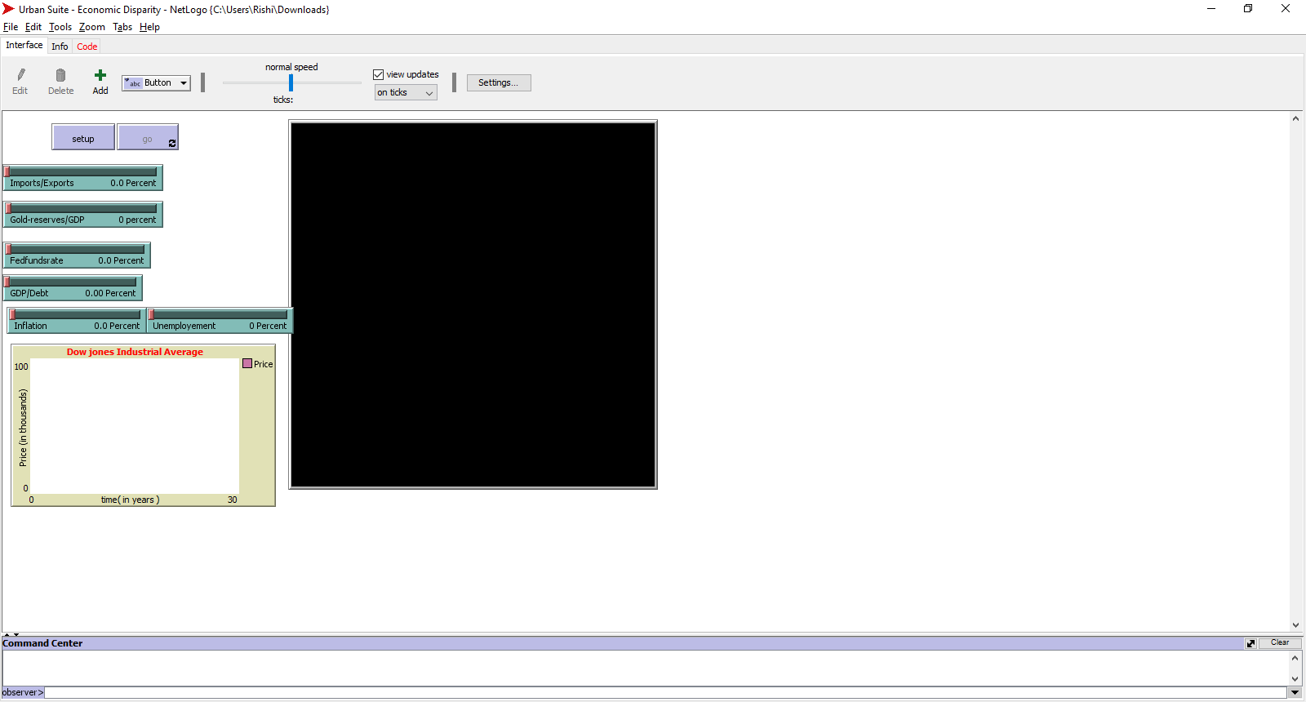

breed [Imports/Exports]

breed [Gold-reserves/GDP]

breed [Fedfundsrate]

breed [GDP/Debt]

breed [Inflation]

breed [Unemployement]

breed [Dowjones]

to setup

clear-all

set view-mode "quality"

setup-Inflation

setup-Unemplyement

end

to Imports/Exports

if increase by 1

ask

[

Gold-reserves/GDP decrease by 0.1

Fedfundsrate increase by 0.1

GDP/Debt decrease by 0.01

Inflation increase by 0.1

Unemployement increase by 0.1

Dowjones decrease by 1000

]

end

to Imports/Exports

if decrease by 1

ask

[

Gold-reserves/GDP increase by 0.1

Fedfundsrate decrease by 0.1

GDP/Debt increase by 0.01

Inflation decrease by 0.1

Unemployement decrease by 0.1

Dowjones decrease by 1000

]

end

to Gold-reserves/GDP

if increase by 1

ask

[

Imports/Exports decrease by 0.1

Fedfundsrate increase by 1.5

GDP/Debt increase by 0.01

Inflation increase by 0.1

Unemployement decrease by 0.1

Dowjones decrease by 5000

]

end

to Gold-reserves/GDP

if decrease by 1

ask

[

Imports/Exports increase by 0.1

Fedfundsrate decrease by 1.5

GDP/Debt decrease by 0.01

Inflation decrease by 0.1

Unemployement increase by 0.1

Dowjones increase by 5000

]

end

to Fedfundsrate

if increase by 1

ask

[

Imports/Exports increase by 3

GDP/Debt increase by 0.1

Gold-reserves/GDP increase by 0.1

Inflation increase by 0.15

Unemployement decrease by 0.15

Dowjones increase by 3000

]

end

to Fedfundsrate

if decrease by 1

ask

[

Imports/Exports decrease by 3

GDP/Debt decrease by 0.1

Gold-reserves/GDP decrease by 0.1

Inflation decrease by 0.15

Unemployement increase by 0.15

Dowjones decrease by 3000

]

end

to Inflation

if Inflation increase by 1

ask

[

Imports/Exports increase by 2

GDP/Debt increase by 0.30

Gold-reserves/GDP decreases by 0.20

Fedfundsrate increase by 0.50

Unemployement increase by 0.10

Dowjones increase by 5000

]

end

to Inflation

if Inflation decrease by 1

ask

[

Imports/Exports decrease by 2

GDP/Debt decrease by 0.30

Gold-reserves/GDP increase by 0.20

Fedfundsrate decrease by 0.5

Unemployement decrease by 0.10

Dowjones decrease by 5000

]

end

to Unemployement

if Unemployement increase by 1

ask

[

Imports/Exports decrease by 1.5

GDP/Debt decrease by 0.5

Gold-reserves/GDP increases by 0.05

Fedfundsrate increases by 1

Inflation increases by 1.5

Dowjones decreases by 1500

]

end

to Unemployement

if Unemployement decrease by 1

ask

[

Imports/Exports increase by 1.5

GDP/Debt increase by 0.5

Gold-reserves/GDP decrease by 0.05

Fedfundsrate decrease by 1

Inflation decreases by 1.5

Dowjones increases by 1500

]

end

to GDP/Debt

if GDP/Debt increase by 1

ask

[

Imports/Exports decrease by 1

Gold-reserves/GDP increase by 0.25

Fedfundsrate increase by 0.5

Inflation increase by 0.75

Dowjones increase by 1500

Unemployement decrease by 0.25

]

end

to GDP/Debt

if GDP/Debt decrease by 1

ask

[

Imports/Exports increase by 1

Gold-reserves/GDP decrease by 0.25

Fedfundsrate decrease by 0.5

Inflation decrease by 0.75

Dowjones decrease by 1500

Unemployement increase by 0.25

]

end

; Copyright 2007 Uri Wilensky.

; See Info tab for full copyright and license.